Faces of Jacksonville Village

Organizations and Communities That Have Participated

Boys and Girls Club

The Bridge of NE Florida

Big Brothers/Big Sisters

Boy Scouts

Children’s International Summer Villages

Chinese Community

Finnish Community

Girl Scouts

Indian Community

Jewish Community

Korean Community

Lutheran Social Services
2004 (Albania, Bosnia)
2005 (Sudan, Gabon, Haiti)
2006 (Lebanon, Liberia, Sierra Leone)
2007 (Afghanistan, Liberia, Lebanon)

Muslim Community

OneJax

Peruvian Community

Polish Community

Russian Community

Scottish Community

Venezuelan Community

A 2-week residential camp experience for youth entering 6th grade in Fall 2008

June 6 - 20, 2007
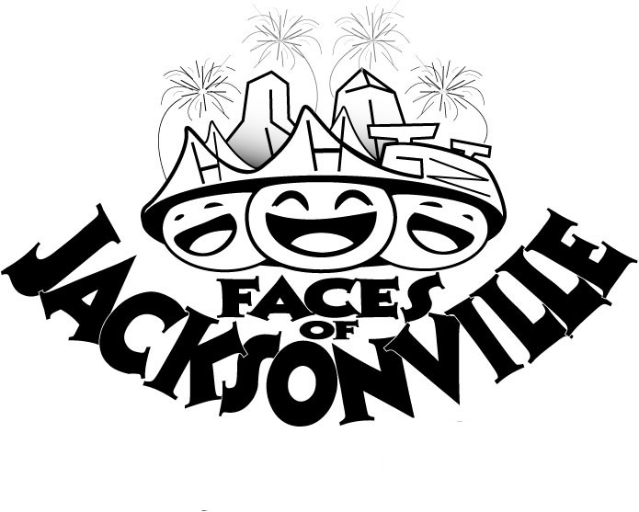

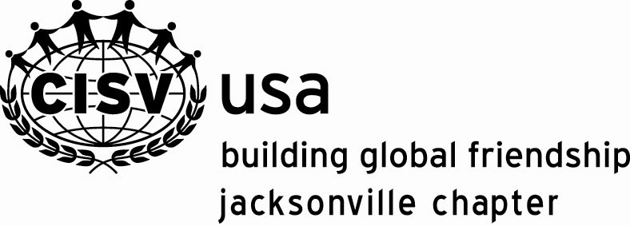

Children’s International Summer Villages
2148 Mango Place
Jacksonville, FL 32207
Phone: 904-306-0820
www.jax.cisvusa.org
- lasting peace is possible
- you're never too young to learn
- friendships are possible even if
you are different
- in making new and exciting friendships
- in seeing the world through new eyes

Presented by:

Carol Daniels – (904) 641-6484
Carol61@bellsouth.net
Vickie Breedlove – (904) 641-8632
vickiebreedlove@aol.com

Faces of Jacksonville Village

If you believe...

